ACTIVITY-BASED-LEARNING

Name: Ellil Blessy Johns
Roll number: 26000019
Branch: CSE
Section: 01
Year: 2026-30

Case Study 05 : Digital Library Management Interface

Problem statement
Design a library website with book categories, book covers, author details, availability labels, search and filter interface elements, and library rules. Use CSS Grid and structured tables for displaying catalog information.

Explanation
I created a Digital Library Management Interface named The Reading Room to display a collection of popular books in an organized manner. The website includes a navigation bar, an introductory section, book categories, six book cards with cover images and author details, availability labels, search and filter controls, a book catalog table, and library rules.
HTML was used to structure the webpage and display the book information. CSS was used to style the website with suitable colors, fonts, spacing, borders, and layouts. Flexbox and CSS Grid were used to arrange the navigation links, book cards, and category items.

HTML Tags Used
- <!DOCTYPE html> – Declares the document as HTML5.
- <html> – Defines the root element of the webpage.
- <head> – Contains the webpage metadata, title, and stylesheet link.
- <meta> – Defines character encoding and viewport settings.
- <title> – Sets the browser tab title.
- <link> – Connects the external CSS file to the HTML document.
- <body> – Contains all visible webpage content.
- <header> – Displays the website logo and navigation bar.
- <nav> – Groups the navigation links.
- <a> – Creates links to different sections of the webpage.
- <section> – Divides the webpage into categories, books, catalog, and rules.
- <div> – Groups related elements for layout and styling.
- <h1>, <h2>, <h3> – Display headings and book titles.
- <p> – Displays descriptions, author names, and other text.
- <br> – Inserts a line break in the main heading.
- <input> – Creates the book search field.
- <select>, <option> – Create category and availability dropdowns.
- <article> – Represents an individual book card.
- <img> – Displays book cover images.
- <span> – Displays compact book availability labels.
- <table>, <tr>, <th>, <td> – Display the book catalog in rows and columns.
- <footer> – Displays the copyright and closing information.

CSS Properties Used
- box-sizing – Controls how element dimensions are calculated.
- scroll-behavior – Enables smooth scrolling between webpage sections.
- margin – Adds space outside elements.
- padding – Adds space inside elements.
- font-family – Sets the font style.
- font-size – Sets the text size.
- font-weight – Controls the thickness of text.
- color – Sets the text color.
- background – Sets background colors and other background effects.
- display – Defines the layout behavior of elements.
- justify-content – Aligns and distributes items along the main axis.
- align-items – Aligns items along the cross axis.
- gap – Adds space between flex or grid items.
- grid-template-columns – Defines the number and size of grid columns.
- width and height – Set element dimensions.
- object-fit – Controls how book cover images fit their containers.
- border and border-bottom – Add borders and separators.
- border-radius – Rounds the corners of elements.
- text-align – Aligns text horizontally.
- text-decoration – Controls link decorations such as underlines.
- :hover – Applies styles when the pointer moves over an element.
- nth-child(even) – Selects even-numbered table rows for alternating styling.

Special Features
- The website displays six book cards with book covers, titles, authors, descriptions, and availability status.
- CSS Grid organizes the book cards into columns.
- Flexbox arranges the navigation links and category items.
- The catalog table displays book titles, authors, categories, and availability.
- Different colors distinguish available and borrowed books.
- Internal navigation links allow users to move between webpage sections.

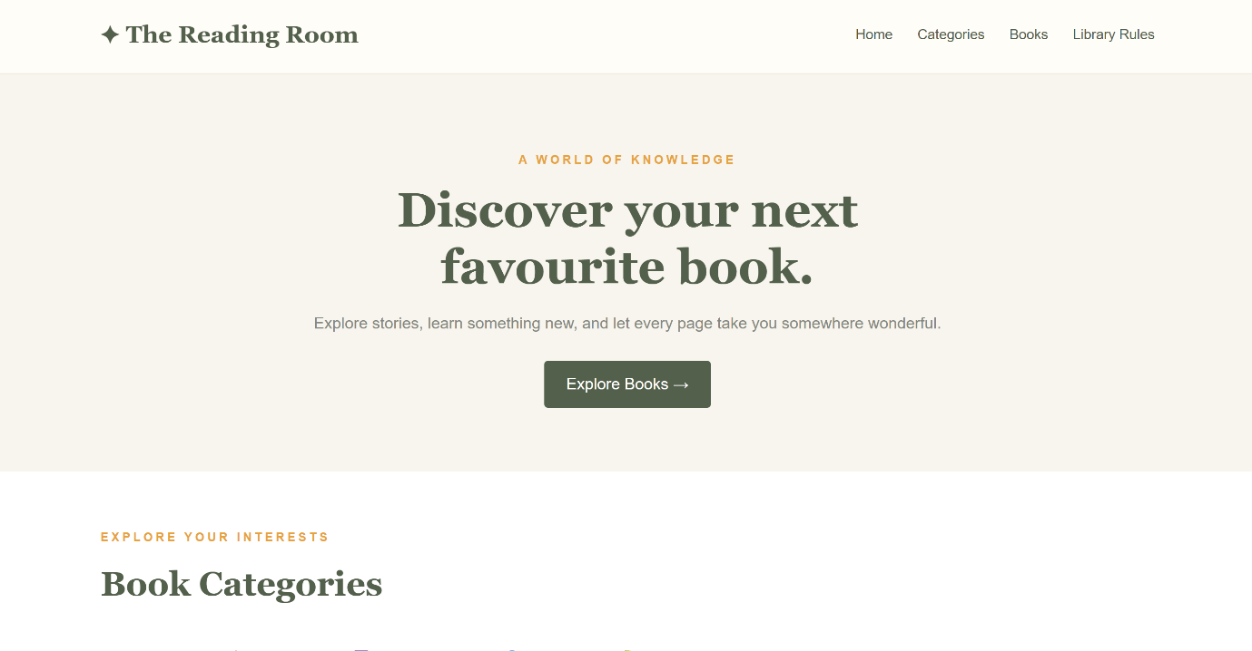
Website Screenshots
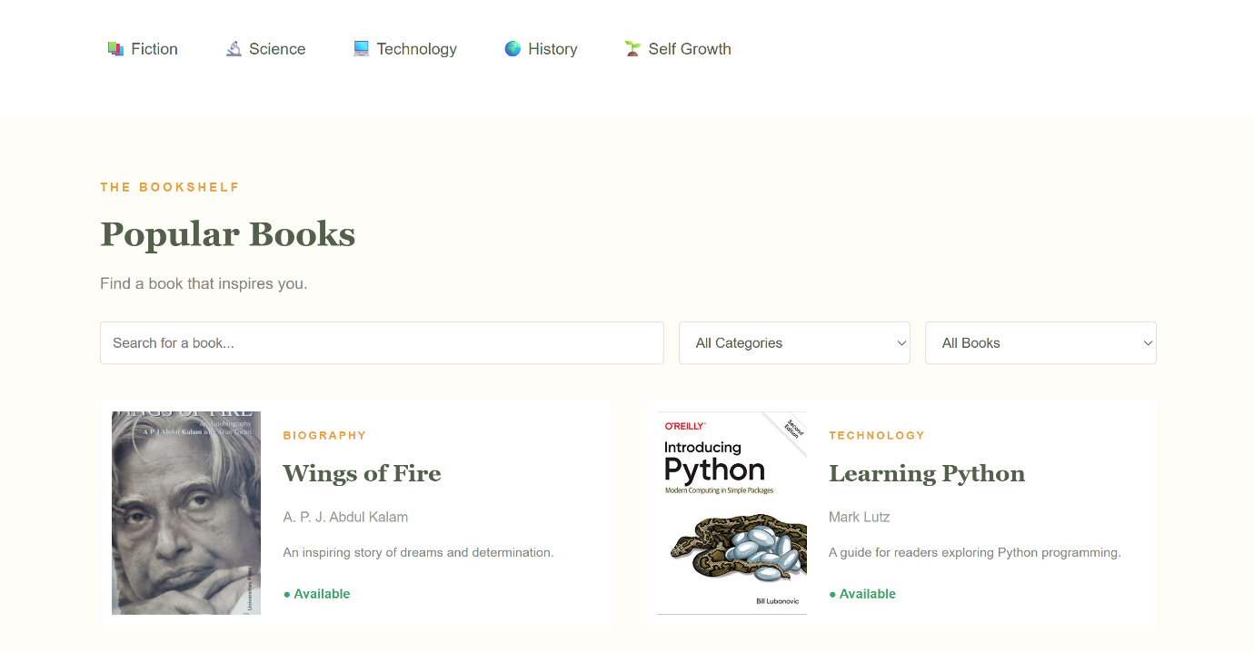

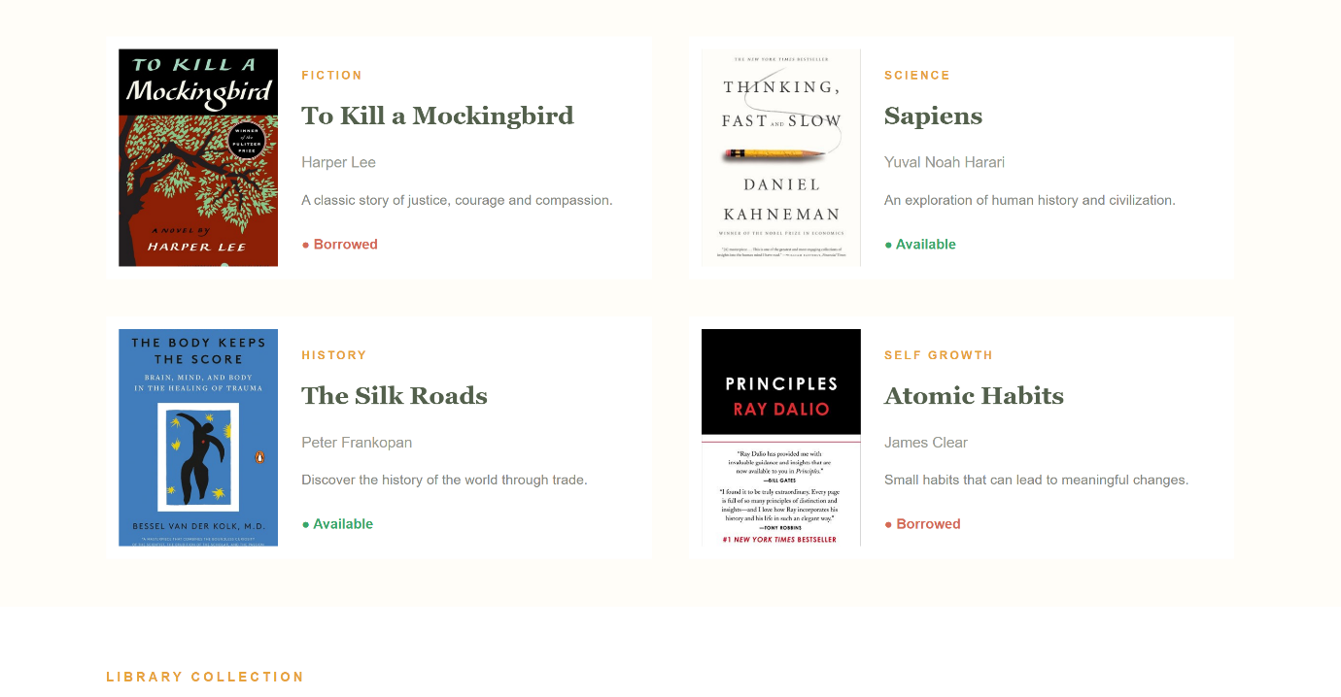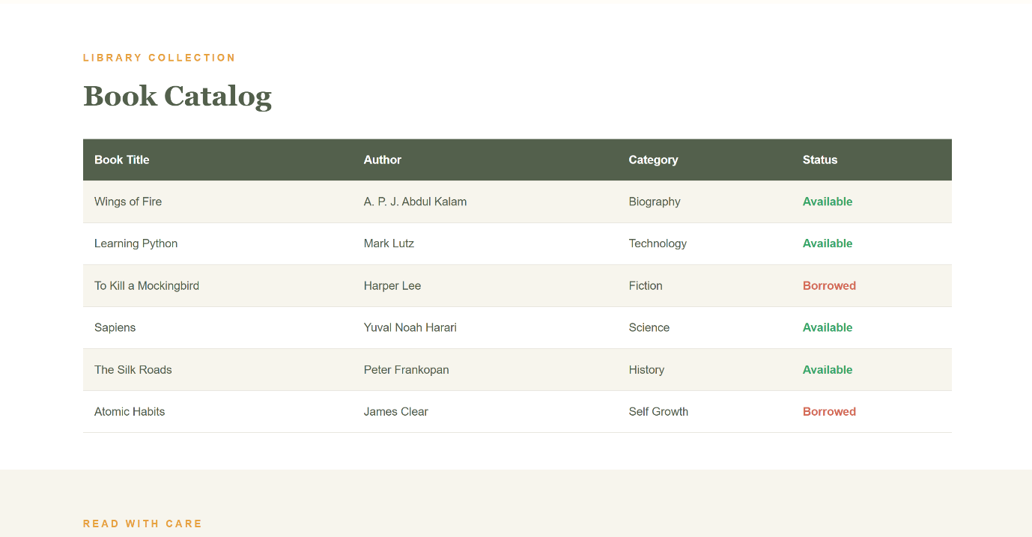
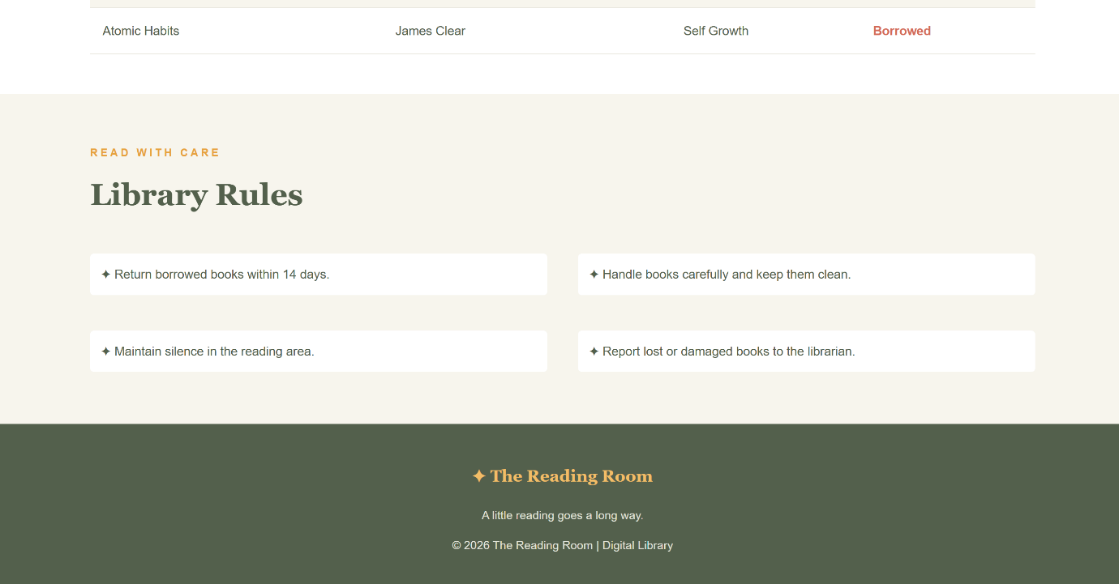

Case Study 12 : Doctor Appointment Booking Interface

Problem statement
Design a website displaying doctor profiles, specializations, consultation timings, available appointment slots, and patient registration fields. Focus on clear form labels and easy navigation.
Explanation
I created a Doctor Appointment Booking Interface named CarePlus to help users explore doctors and request appointments through a simple webpage. The website includes a navigation bar, an introductory section, three doctor profile cards, consultation timings, booking information boxes, and a patient registration form.
HTML was used to structure the webpage, display doctor details, and create form fields for patient information. CSS was used to improve the website's appearance through colors, typography, spacing, borders, and shadows. Flexbox was used to arrange the doctor cards and booking section. The form includes fields for the patient's name, email address, phone number, doctor selection, appointment date, preferred time, and additional information.

HTML Tags Used
- <!DOCTYPE html> – Declares the document as HTML5.
- <html> – Defines the root element of the webpage.
- <head> – Contains metadata, the webpage title, and stylesheet reference.
- <meta> – Defines character encoding and viewport settings.
- <title> – Sets the browser tab title.
- <link> – Connects the external CSS file to the HTML document.
- <body> – Contains all visible webpage content.
- <header> – Displays the CarePlus logo and navigation bar.
- <nav> – Groups the navigation links.
- <a> – Creates links to the home, doctors, and booking sections.
- <section> – Separates the hero, doctors, and booking areas.
- <div> – Groups doctor details, booking information, and form elements.
- <h1>, <h2>, <h3> – Display main headings, section headings, and doctor names.
- <p> – Displays descriptions, specializations, and consultation timings.
- <br> – Inserts a line break in the main heading.
- <img> – Displays doctor profile images.
- <form> – Groups the patient registration fields.
- <label> – Describes each form field.
- <input> – Collects the patient's name, email, phone number, and other information.
- <select>, <option> – Provide dropdown choices for doctors and appointment times.
- <textarea> – Allows users to enter additional information.
- <button> – Creates the appointment form submission button.
- <footer> – Displays the closing information and copyright details.

CSS Properties Used
- box-sizing – Controls how the width and height of elements are calculated.
- scroll-behavior – Enables smooth scrolling between sections.
- margin – Adds space outside elements.
- padding – Adds space inside elements.
- font-family – Sets the font style.
- font-size – Sets the text size.
- font-weight – Controls the thickness of text.
- line-height – Controls spacing between lines of text.
- color – Sets the text color.
- background – Sets the background color.
- display – Defines the layout behavior of elements.
- justify-content – Aligns and distributes items along the main axis.
- align-items – Aligns items along the cross axis.
- gap – Adds space between layout items.
- width, height – Set element dimensions.
- max-width – Limits the maximum width of an element.
- object-fit – Controls how doctor images fit inside their containers.
- border – Adds borders around elements.
- border-radius – Rounds the corners of cards, images, and form fields.
- box-shadow – Adds shadows to doctor cards and the registration form.
- text-decoration – Removes default underlines from links.
- :hover – Applies styling when the mouse pointer moves over a button or link.
- :focus – Highlights the form field currently selected by the user.
- resize – Controls whether a textarea can be resized.

Special Features
- Displays three doctor profiles with names, specializations, descriptions, and consultation timings.
- Uses Flexbox to arrange doctor cards horizontally.
- Uses circular doctor images with border-radius: 50%.
- Provides a patient registration form with different input types.
- Uses dropdown lists for doctor and time-slot selection.
- Highlights active form fields using the :focus pseudo-class.
- Adds hover effects to appointment buttons.
- Uses a teal-and-white color scheme for a clean healthcare design.

Website Screenshots
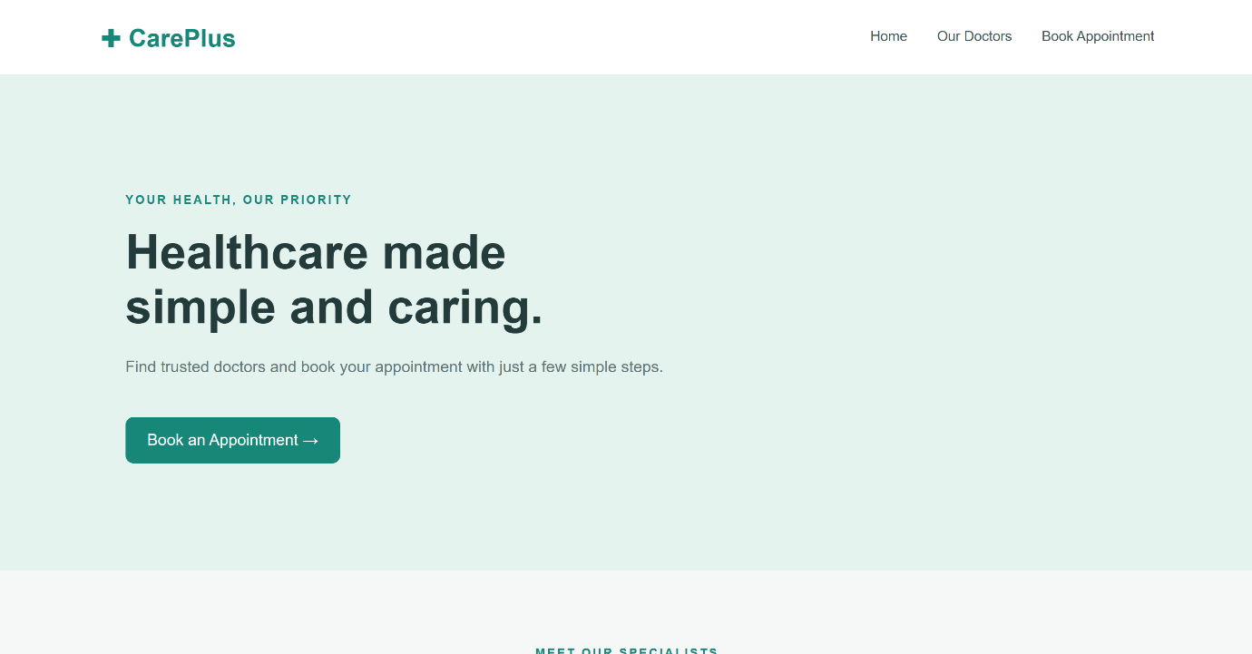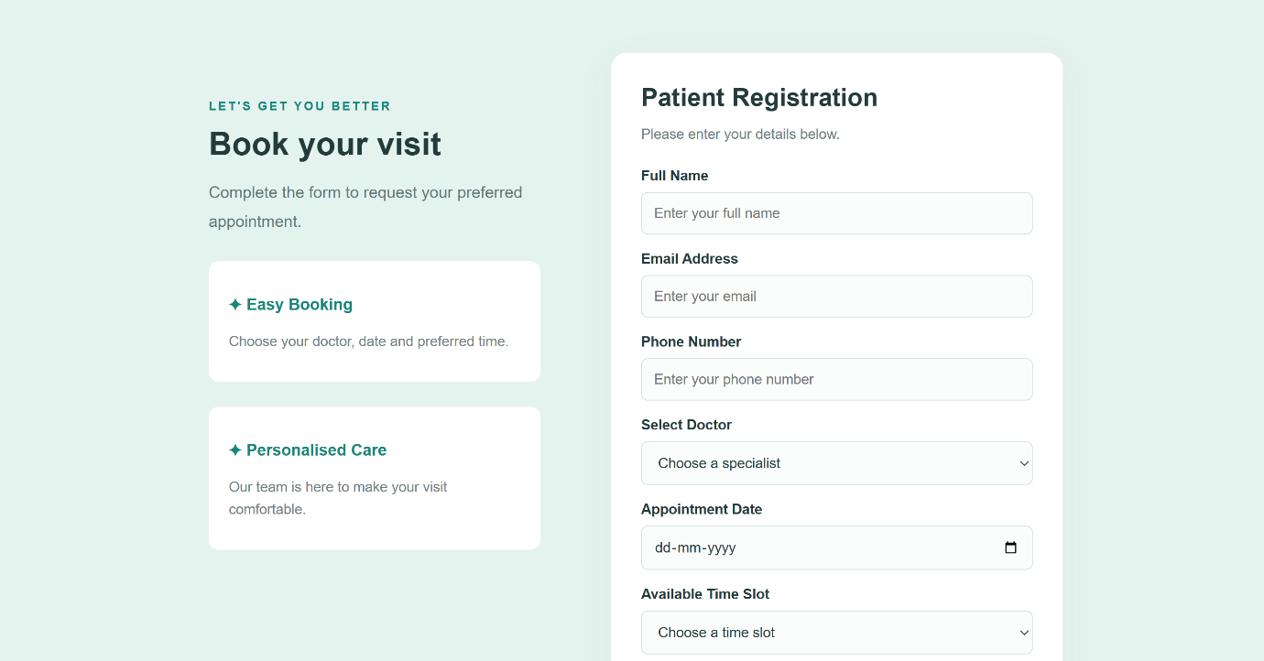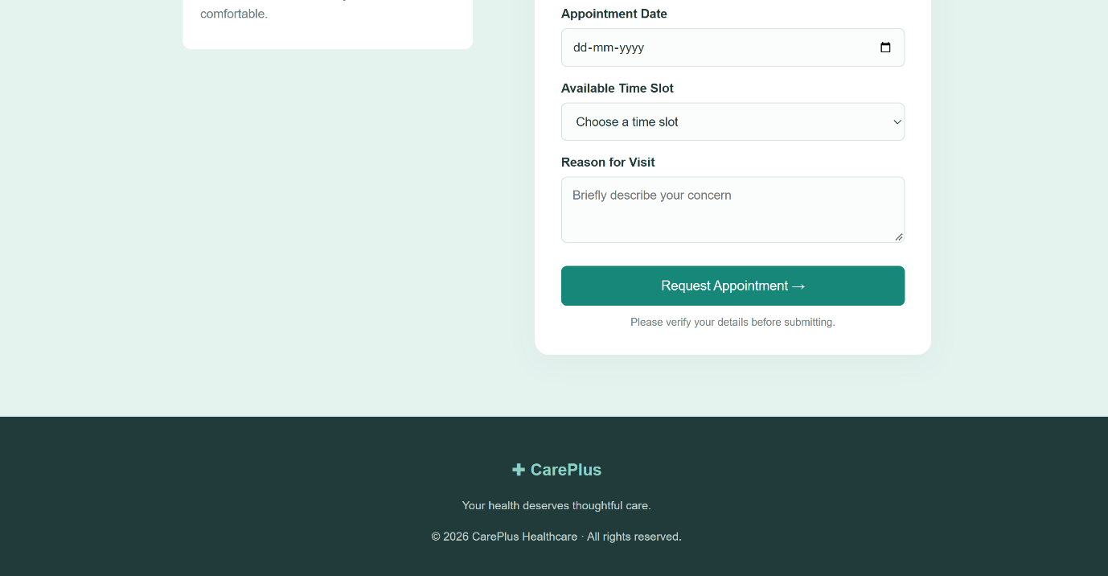

Case Study 26 : College Fest Management Website

Problem statement
Build a college festival website displaying technical events, cultural competitions, workshops, schedules, event coordinators, rules, and registration forms. Use category-based cards and responsive event banners.

Explanation
I created a College Fest Management Website named Ignite 2026 to present information about a college festival and its activities. The website includes a header with navigation links, a hero banner with the festival date and venue, an introduction section, six event cards, an event schedule table, coordinator profiles, a registration form, and festival rules.
HTML was used to organize the webpage content, display event images, create the schedule table, and collect participant information through a registration form. CSS was used to design the webpage with a dark purple, coral, and neutral color scheme. CSS Grid was used to arrange event and coordinator cards, while Flexbox was used for the navigation bar. Hover effects, a background image with a dark overlay, and styled form elements improve the overall appearance.

HTML Tags Used
- <!DOCTYPE html> – Declares the document as HTML5.
- <html> – Defines the root element of the webpage.
- <head> – Contains metadata, the webpage title, and stylesheet reference.
- <meta> – Defines character encoding and viewport settings.
- <title> – Sets the browser tab title.
- <link> – Connects the external CSS file to the HTML document.
- <body> – Contains all visible webpage content.
- <header> – Displays the festival logo and navigation bar.
- <nav> – Groups navigation links.
- <a> – Creates links to event, schedule, and registration sections.
- <section> – Divides the webpage into different content areas.
- <div> – Groups event cards, coordinator profiles, and other elements.
- <h1>, <h2>, <h3> – Display the festival name and section and event headings.
- <p> – Displays descriptions, dates, event times, and coordinator information.
- <span> – Highlights the festival year in the logo and event category labels.
- <br> – Inserts a line break in the hero heading.
- <article> – Represents an individual event card.
- <img> – Displays event photographs.
- <strong> – Emphasizes labels such as coordinator names and event times.
- <small> – Displays coordinator email addresses in smaller text.
- <table> – Displays the event schedule.
- <thead> – Groups the table's heading row.
- <tbody> – Groups the table's data rows.
- <tr> – Defines a table row.
- <th> – Defines a table heading cell.
- <td> – Defines a regular table cell.
- <form> – Groups the festival registration fields.
- <label> – Describes each form field.
- <input> – Collects the participant's name, email, and college name.
- <select>, <option> – Create the event selection dropdown.
- <textarea> – Allows participants to enter additional information.
- <button> – Creates the registration submission button.
- <ul>, <li> – Display the festival rules as a list.
- <footer> – Displays the closing message and copyright information.

CSS Properties Used
- margin – Adds space outside elements.
- padding – Adds space inside elements.
- box-sizing – Controls how element dimensions are calculated.
- font-family – Sets the font style.
- font-size – Sets the text size.
- font-weight – Controls text thickness.
- line-height – Controls spacing between lines.
- letter-spacing – Adds spacing between letters.
- color – Sets the text color.
- background – Sets background colors, images, and gradients.
- display – Defines the layout behavior of elements.
- flex-wrap – Allows navigation items to wrap onto additional lines.
- justify-content – Distributes items along the main axis.
- align-items – Aligns items along the cross axis.
- gap – Adds spacing between flex or grid items.
- grid-template-columns – Defines the columns of a grid layout.
- width, height – Set element dimensions.
- max-width – Limits the maximum width of an element.
- object-fit – Controls how event images fit inside their containers.
- border, border-bottom – Add borders and table row separators.
- border-radius – Rounds the corners of cards and form fields.
- overflow – Controls content that exceeds an element's boundaries.
- overflow-x: auto – Allows horizontal scrolling when the schedule table is too wide.
- text-align – Aligns text.
- text-decoration – Removes default link underlines.
- transition – Makes changes in CSS properties appear gradual.
- transform – Moves an element, such as lifting an event card slightly upward.
- clamp() – Sets a minimum, preferred, and maximum value for a responsive property.
- :hover – Applies styles when the mouse pointer moves over an element.
- :focus – Highlights the form field currently selected by the user.
- ::before – Inserts generated content before an element's content.
- content – Specifies the content inserted by a pseudo-element.

Special Features
- Displays six event cards for technical, cultural, and workshop activities.
- Uses CSS Grid to arrange the event cards into three columns.
- Displays a festival hero banner with a background image and a dark gradient overlay.
- Uses clamp() to adjust the main heading size according to the viewport width.
- Displays an event schedule in a structured HTML table.
- Uses CSS Grid to arrange coordinator profiles.
- Provides a registration form with text fields, a dropdown, and a textarea.
- Uses hover transitions to create a lifting effect on event cards.
- Uses the ::before pseudo-element to display checkmarks beside festival rules.
- Uses a dark purple and coral color scheme to create a modern festival design.

Website Screenshots

